Paper ID: NSALS ’26-

GUIDELINES for EXTENDED ABSTRACT

Please kindly note that the Extended abstract will not be published in the symposium. The Extended abstract is used only for the reviewing process.

Key Requirements
- Original Undergraduate Research:
  - The abstract must be based on original work conducted by you and your research team, as part of your undergraduate studies within the last four years.
  - It cannot be based on work done outside of undergraduate studies (e.g., Master's/MPhil thesis, external internships).
- No Previously Published or Presented Work
  - Your research must not have been published in any journal, proceedings, or conference or presented at any other symposium, seminar, or research forum.
  - Only first-time submissions are allowed.
- No Use of AI Technology in Writing:
  - The abstract must be written entirely by you-not generated, or assisted, by AI tools or other AI-driven writing aids.
  - This includes writing, editing, and paraphrasing.

TITLE OF THE STUDY PRESENTED IN THE ABSTRACT
The Title of the extended abstract should be the same as that of the abstract submitted. The title should appear in the correct style (All Caps [except for scientific names], 12pt. Times New Roman, boldface, left-justified).)

INTRODUCTION
It should provide background information about the work briefly and its significance while highlighting other relevant literature and specifying how it relates to or differs from your work. It would be best if you would also discuss the scope and limitations of your study in the introduction. Please cite relevant sources as evidence for or justification of an argument or statement. Try to include only 4-5 in-text citations in the introduction section.

RESEARCH PROBLEM(S)/ISSUE(S) (IF RELEVANT)
In this section, you might mention specific issues, difficulties, contradictions, or gaps in knowledge that you will address in your research. You might look for practical problems aimed at contributing to change or theoretical issues aimed at expanding knowledge.

OBJECTIVE(S)
Provide a clear statement/s of goals and objectives/specific objectives of the project that should be understandable to reviewers/scholars from various other disciplines.

THEORETICAL CONSIDERATIONS AND EMPIRICAL EVIDENCE (IF APPLICABLE)
Provide details on specific and major theoretical aspects here (if relevant).

METHODOLOGY
The methodology section should be descriptive enough so that the reader can identify what was done. References to the methodology are appropriate. Within the methodology section, you can apply as many first-, second-and third-level headings as you need.

RESULTS AND DISCUSSION
This section should be comprehensive and concise. You may include a description of the main findings of the research, using data, figures, tables, etc. Also, interpretations of the results for readers and provides the significance of the findings in the discussion section with appropriate references. The findings/results and discussion sections may be combined. Within the results and discussion section, you can use as many first-, second, and third-level headings as you need.

CONCLUSION(S)
A concise brief paragraph is expected to pull everything together to help in clarifying the research work and remind the reader of the main arguments and their importance. You can also suggest possible future research on the topic if relevant.

REFERENCES
References should be cited within your extended abstract in a consistent style.
Extended Abstract Preparation - Specific Guidelines

Extended Abstract Length
Extended abstracts should be at least three, but not more than five A4 size pages in length, including the references. The word limit is 1,500 - 2,000 words.

Using Predefined Styles
The style elements identified in this section have been defined for you to lend consistency to the group of papers. Times New Roman is the preferred font type.
All abstracts should be written in English language using MS Word (.docx/.doc format) or appropriate tool/software.

TABLE FORMAT
Tables must be created using the Microsoft Word or WordPerfect table functions and included as part of the text immediately after the first point of reference. DO NOT place them at the end of your extended abstract. For improved readability, keep your tables as simple as possible. All the tables should use only three horizontal lines (no lines to separate columns) and be centered in the main body/text.
Table 1. Title of the table (12-point Times New Roman, table title should appear immediately above the table)
Month | Jan. | Feb. | Mar. | Apr. | May. | Jun.
Arrivals¹ | 0,000 | 000 | 00,000 | 000,000 | 000 | 00,000
Departures | 0,000 | 000 | 00,000 | 000,000 | 000 | 00,000
Total | 0,000 | 000 | 00,000 | 000,000 | 000 | 00,000
¹Bulleted and numbered lists should be created using the word processing toolbar functions for these items (10pt, Times New Roman, left-justified)
Any explanations of table data should immediately follow the table and be formatted as plain body text. DO NOT include table explanations within tables. Notations and references, such as superscript letters and number notations, are acceptable within the table. A legend describing notes should follow directly underneath the table.
Table numbers should be indicated in the text as (Table 1) if it is a part of a sentence. If several tables are mentioned in the text, it would be "(Table 1 and 2) or as appropriate.

FIGURE FORMAT
Figures include charts, graphs, and drawings. Pictures must be sharp enough and clear. All figures and other graphics should be embedded or electronically placed within the text immediately after the first point of reference. Please do not put them on separate pages at the end of your extended abstract.

All the figures should be centered on the main body/text. Figures must be labeled properly with the X, and Y axes marked/labeled. Include a legend as appropriate. The figure should be easily understandable and contain enough information in it, including the caption.You may use double X/Y axes if necessary. The figure caption should be 12 pt, Times New Roman font, left-justified, and appear immediately below the figure.

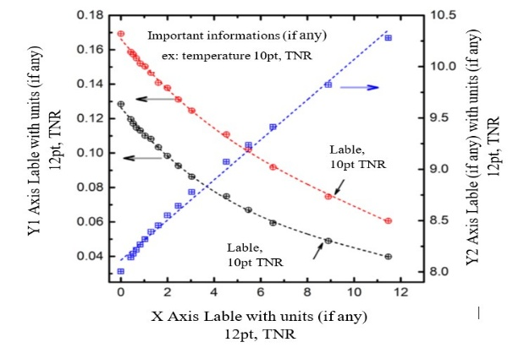
Figure 1: Figure caption/title (The figure caption should be 12 pt, Times New Roman font, left-justified, and appear immediately below the figure, with enough information to describe the figure)
Figure numbers should be indicated in the text as (Fig. 1) or Fig. 1, if it is a part of a sentence. If several figures are mentioned in the text, it would be "(Fig. 1 and 2) / (Fig. 1a, b and c)" or "Fig 1 and 2 / Fig. 1a and b", as appropriate.

IMPORTANT: A PDF VERSION OF THE EXTENDED ABSTRACT PREPARED ACCORDING TO THE GIVEN GUIDELINES SHOULD BE SUBMITTED THROUGH THE CMT SYSTEM BEFORE THE DEADLINE.

